Dear Students,

You may like to log on to this useful website to learn some aspects which may help you in paper writing, research methods, and reporting.

<https://researchmethod.net/category/paper/>

# Category - Research Paper Guide

[](https://researchmethod.net/how-to-cite-research-paper/)

## [How to Cite Research Paper – All Formats and Examples](https://researchmethod.net/how-to-cite-research-paper/)

[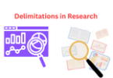](https://researchmethod.net/delimitations/)

## [Delimitations in Research – Types, Examples and Writing Guide](https://researchmethod.net/delimitations/)

[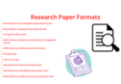](https://researchmethod.net/research-paper-format/)

## [Research Paper Format – Types, Examples and Templates](https://researchmethod.net/research-paper-format/)

[](https://researchmethod.net/research-design/)

## [Research Design – Types, Methods and Examples](https://researchmethod.net/research-design/)

[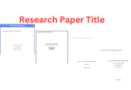](https://researchmethod.net/research-paper-title/)

## [Research Paper Title – Writing Guide and Example](https://researchmethod.net/research-paper-title/)

[](https://researchmethod.net/research-paper-introduction/)

## [Research Paper Introduction – Writing Guide and Examples](https://researchmethod.net/research-paper-introduction/)

[](https://researchmethod.net/research-paper-conclusion/)

## [Research Paper Conclusion – Writing Guide and Examples](https://researchmethod.net/research-paper-conclusion/)

[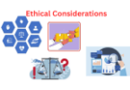](https://researchmethod.net/ethical-considerations/)

## [Ethical Considerations – Types, Examples and Writing Guide](https://researchmethod.net/ethical-considerations/)

[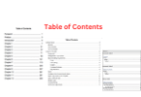](https://researchmethod.net/table-of-contents/)

## [Table of Contents – Types, Formats, Examples](https://researchmethod.net/table-of-contents/)

[](https://researchmethod.net/scope-of-the-research/)

## [Scope of the Research – Writing Guide and Examples](https://researchmethod.net/scope-of-the-research/)

[](https://researchmethod.net/research-paper/)

## [Research Paper – Structure, Examples and Writing Guide](https://researchmethod.net/research-paper/)

[](https://researchmethod.net/future-research-in-thesis/)

## [Future Research – Thesis Guide](https://researchmethod.net/future-research-in-thesis/)

[](https://researchmethod.net/methodology/)

## [Research Methodology – Types, Examples and writing Guide](https://researchmethod.net/methodology/)

[](https://researchmethod.net/research-objectives/)

## [Research Objectives – Types, Examples and Writing Guide](https://researchmethod.net/research-objectives/)

[](https://researchmethod.net/appendices/)

## [Appendices – Writing Guide, Types and Examples](https://researchmethod.net/appendices/)

[](https://researchmethod.net/how-to-publish-a-research-paper/)

## [How to Publish a Research Paper – Step by Step Guide](https://researchmethod.net/how-to-publish-a-research-paper/)

[](https://researchmethod.net/implications-in-research/)

## [Implications in Research – Types, Examples and Writing Guide](https://researchmethod.net/implications-in-research/)

[](https://researchmethod.net/apa-research-paper-format/)

## [APA Research Paper Format – Example, Sample and Writing Guide](https://researchmethod.net/apa-research-paper-format/)

[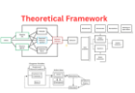](https://researchmethod.net/theoretical-framework/)

## [Theoretical Framework – Types, Examples and Writing Guide](https://researchmethod.net/theoretical-framework/)

[](https://researchmethod.net/context-of-the-study/)

## [Context of the Study – Writing Guide and Examples](https://researchmethod.net/context-of-the-study/)

[](https://researchmethod.net/research-paper-outline/)

## [Research Paper Outline – Types, Example, Template](https://researchmethod.net/research-paper-outline/)

[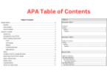](https://researchmethod.net/apa-table-of-contents/)

## [APA Table of Contents – Format and Example](https://researchmethod.net/apa-table-of-contents/)

[](https://researchmethod.net/research-paper-abstract/)

## [Research Paper Abstract – Writing Guide and Examples](https://researchmethod.net/research-paper-abstract/)

[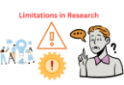](https://researchmethod.net/limitations-in-research/)

## [Limitations in Research – Types, Examples and Writing Guide](https://researchmethod.net/limitations-in-research/)

[](https://researchmethod.net/significance-of-the-study/)

## [Significance of the Study – Examples and Writing Guide](https://researchmethod.net/significance-of-the-study/)

[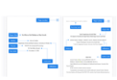](https://researchmethod.net/research-paper-title-page/)

## [Research Paper Title Page – Example and Making Guide](https://researchmethod.net/research-paper-title-page/)

[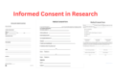](https://researchmethod.net/informed-consent-in-research/)

## [Informed Consent in Research – Types, Templates and Examples](https://researchmethod.net/informed-consent-in-research/)

[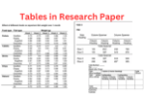](https://researchmethod.net/tables-in-research-paper/)

## [Tables in Research Paper – Types, Creating Guide and Examples](https://researchmethod.net/tables-in-research-paper/)

[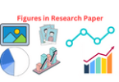](https://researchmethod.net/figures-in-research-paper/)

## [Figures in Research Paper – Examples and Guide](https://researchmethod.net/figures-in-research-paper/)

[](https://researchmethod.net/research-contribution/)

## [Research Contribution – Thesis Guide](https://researchmethod.net/research-contribution/)